

**Final Report**

**[Quiz Game]**

**Skill Development Project I - ICT 1108**

**Bachelor of Information and Communication Technology (BICT)**

**Degree Programme**

Department of Information and Communication Technology

Faculty of Technology

Rajarata University of Sri Lanka

Mihintale

**Details of the Project**

Project Title : Quiz Game

Group Number : 08

Group Name : Enforcers

Submission Date : 12/10/2023

Group Members :

|  |  |  |
| --- | --- | --- |
| Student Name | Index Number | Signature |
| A.J.M.I.MALINDA | 1391 |  |
| R.M.M.K.B.RATHNAYAKE | 1353 |  |
| W.W.P.D.WIJERATHNA | 1398 |  |
| W.A.D.R.DEVINDA | 1384 |  |
| A.K.P.H.IMASHA | 1315 |  |
| K.G.I.D.KAMNATHILAKA | 1389 |  |

Internal Supervisor(s) :

Name :Malki sandamini_

Designation : lecture

Department : ICT department

Email : msjayawa@tec.rjt.ac.lk

Signature : ________________ Date: _____________

External Supervisor(s) :

Name : ______________________________________

Designation : ______________________________________

Email : ______________________________________

Phone Number : ______________________________________

Signature : ________________ Date: _____________

Table of Contents

**Introduction** 5

**1.1 Introduction** 5

**Problem Statement** 6

**Aim and Objective** 6

**Aim** **Error! Bookmark not defined.**

**Objective** 6

**Approach** 7

**2.1 Scope of the Project** 7

**2.2 End user of the project** 8

**2.3 Functional Requirements** 8

**2.4 Non-Functional Requirements** 9

**Technical approach** 11

**3.1 System Design** 11

**3.3 User Interface Design** 12

**3.4 Methods and Technology Used** 13

**Development** 16

**Conclusion** 17

**References** 17

# **Introduction**

# **1.1 Introduction**

This is a comprehensive and error-free Quiz Game Project in java that is meant to run on an interface.

The quiz game asks a series of questions from the player about different subjects. By playing this game a person can be able to test his knowledge in different fields. A user can access/play 20 questions and they have only one chance to answer each question.

For each correct answer user will get a credit score and at the end of the game, the program will reveal the player’s final score. This game is fun to play and anyone can play game.

This grant is mainly divided into 3 parts..

* 1. General Knowledge.
  2. History of the Computer
  3. Computer Programming

This can use educational knowledge more effectively and can improve knowledge about computer history as well as programming languages. Here you can get an understanding about the use of modern technology as well as entertainment.. 3 also covers a large scope related to the game.JAVA programming language is used as the rendering tool. And an important aspect of this is that there is no age limit ..people of any age can relate to this game ..the main objective is to visually design the game so that the player has a desire to play and the user gets a good knowledge from it.

We included in this app,

• Logging into the app

• Select the category

• Timer to answer the question

• Show the final result

## **1.2 Problem Statement**

There are many quiz applications available currently on the internet. But there are few which provide better understanding between users and the application like, providing proper answers, user query solving, uploading user questions as well as the answer to them, etc. The issue of universal education exists on a global scale. So, this is being developed to increase users’ level of education in a more efficient way because the activities carried out for the development of knowledge in the education system are not more effective. This gives an opportunity to provide knowledge through an attractive and entertaining medium for children who do not acquire knowledge nowadays

## **Aim**

This quiz game system can be used as a short assessment in education and similar fields to improve and measure the development of knowledge, abilities, or skills.

## **Objective**

* To provide players with a convenient and accessible platform for quiz gaming system.
* To Improve and check players’ knowledge
* To attract people for the quiz game without age limit
* To provide a good platform for users to develop their knowledge about various subjects.
* Like; Science, History, Health
* Develop a user-friendly and interactive quiz game application.

# **Approach**

## **2.1 Scope of the Project**

Scope of the Project The scope of a quiz game project may vary depending on the requirements and objectives, but here are some possible components that can be included in the project scope:

1. User Interface: The quiz game should have a user-friendly interface that allows players to select quiz categories, view questions, submit answers, and track their progress.

2. Categories: The quiz game can include different categories of questions, such as history, science, literature, etc., to cater to different interests and age groups.

3. Scoring System: The quiz game should have a scoring system that calculates the score based on the number of correct answers and the time taken to complete the quiz.

4. Timer: The quiz game should have a timer that limits the time for each question and the overall quiz, adding a sense of urgency and excitement to the game.

5. Sound Effects and Background Music: The quiz game can include sound effects and background music to enhance the gaming experience.

These are just a few examples of the possible components that can be included in the project scope of a quiz game. The specific scope will depend on the requirements and objectives of the game.

## **2.2 End user of the project**

This is a creative endeavor designed to cater to the needs and preferences of end users seeking engaging and educational entertainment. This project is designed to promote learning, engagement, and entertainment simultaneously. This project aims to develop a user-friendly, interactive, quiz game, which is targeted at a wide range of end users. The game offers an exciting platform for individuals of all ages and backgrounds to test their testing knowledge or problem-solving skills. The manly focus about science, mathematics knowledge. With an intuitive interface, diverse quiz categories, and a scoring system, this project focuses on delivering a rich user experience. Whether for educational purposes, this quiz game will provide end users with a valuable, intellectually stimulating, and enjoyable gaming experience. Including students, teachers, interested in educational quizzes. There is no age limit any anyone (students, teachers and educators) can play this game and they can improve their knowledge.

## **2.3 Functional Requirements**

1. User Registration and Login

* Users should be able to create accounts and log in to the game.
* User profiles with customizable avatars and usernames may be included.

2. Quiz Creation and Management

* + - Admins should be able to create, edit, and manage quizzes.
    - Quizzes should support different question types (multiple-choice, true/false, open-ended, etc.).
    - Questions should be categorized into topics or difficulty levels.

3. Gameplay Features

* Users can select quizzes to play.
* The game should present questions one at a time and provide a timer for each question.
* Users should be able to answer questions within a time limit.
* The game should keep track of correct and incorrect answers.
* Users should receive immediate feedback on their answers.

4. Security

* Implement user data protection, including secure storage.

## **2.4 Non-Functional Requirements**

1. Performance

* Response Time

The system should provide quick response times to ensure a seamless user experience.

* Scalability

The system should be able to handle a growing number of concurrent users without a significant drop in performance.

* Load Handling

The system should be able to handle a large number of quiz questions and user profiles.

2. Reliability

* Availability

The system should be available with minimum downtime. Should be reliable and available for use 24/7.

* Fault Tolerance

The system should continue to function even in the presence of minor failures.

3. Security

* User Authentication

Implement secure authentication methods to protect user accounts.

* Data Security

Protect user data, including personal information and scores.

* Data Encryption

Sensitive data should be encrypted in transit and at rest.

4. Feedback and Improvement:

* Establish a mechanism for collecting user feedback and a process for making improvements based on that feedback.

5. Usability

* User Interface

Ensure the user interface is intuitive and user-friendly.

Accessibility

Make the quiz game accessible to people with disabilities.

* Cross-Platform Compatibility

Ensure compatibility with various devices and browsers.

# **Technical approach**

## **3.1 System Design**

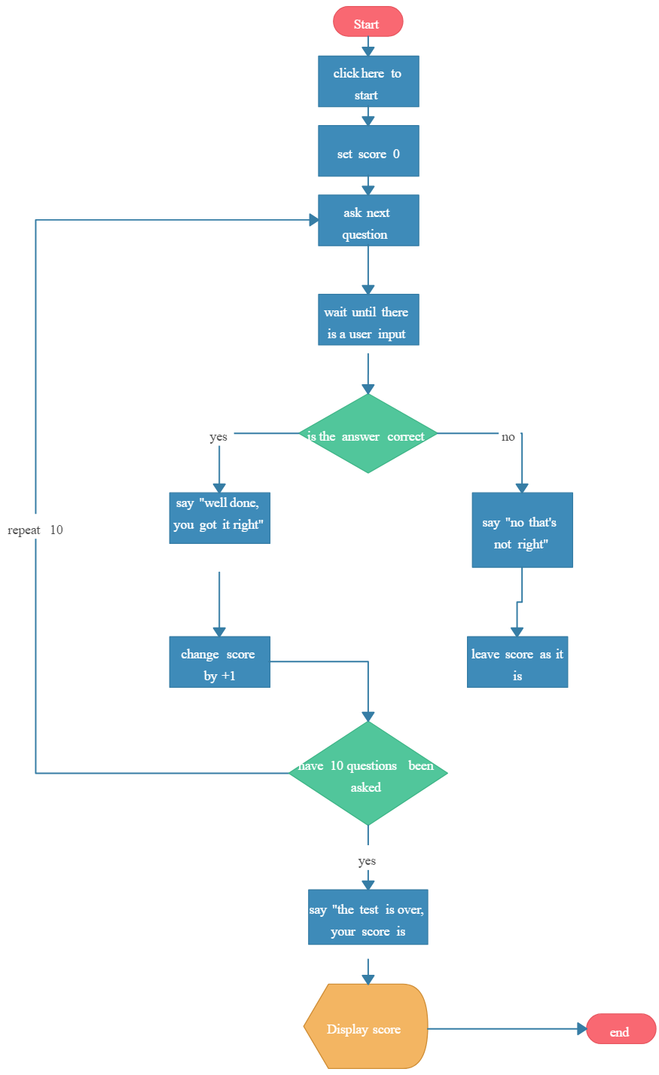

## 

## **3.2 User Interface Design**

User interface is the front-end application view to watch user interacts in order to use the software. User can manipulate and control the software as well as hardware by means of means of users interface.

UI can be graphical, text based, or audio-video based, depending upon the under lying hardware and software combination. UI can be hardware or software or a combination of both.

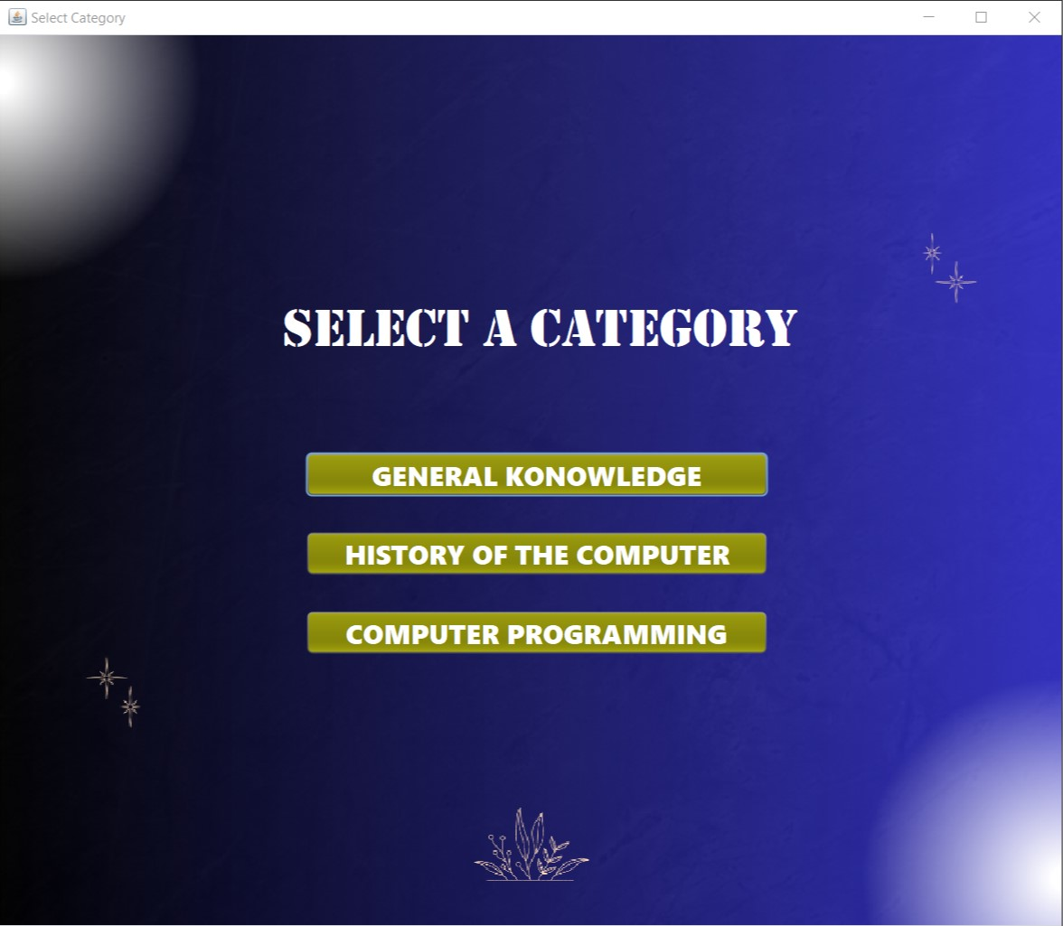

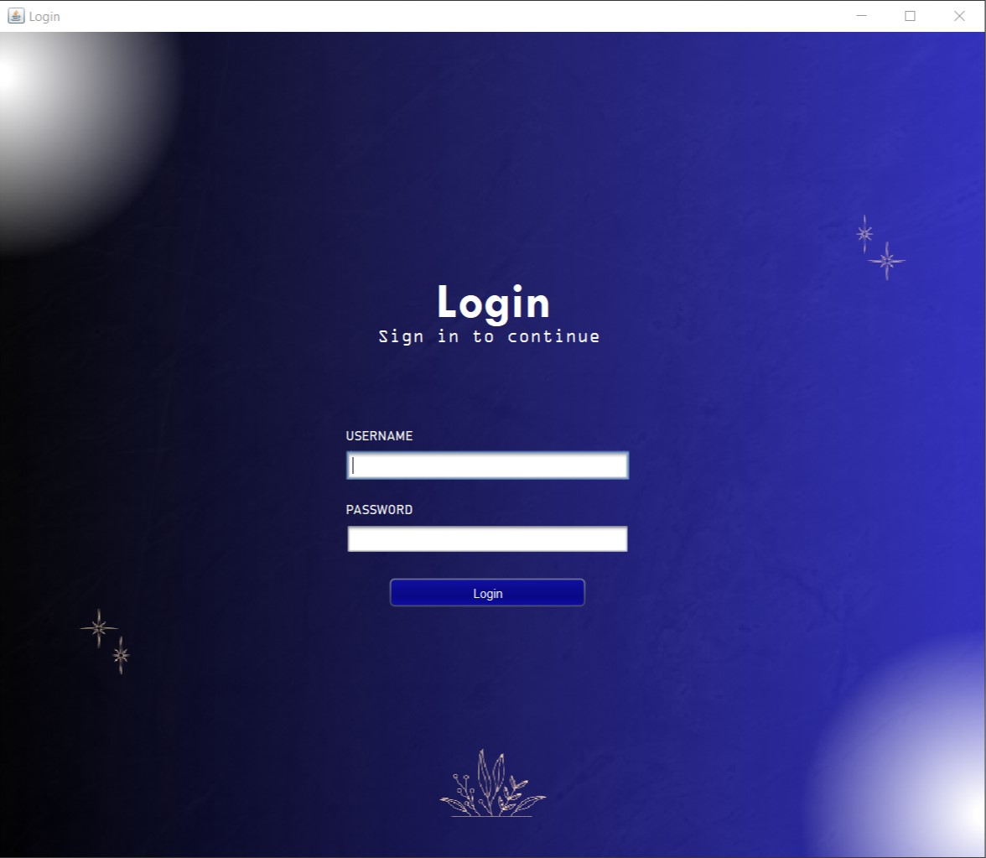

## 

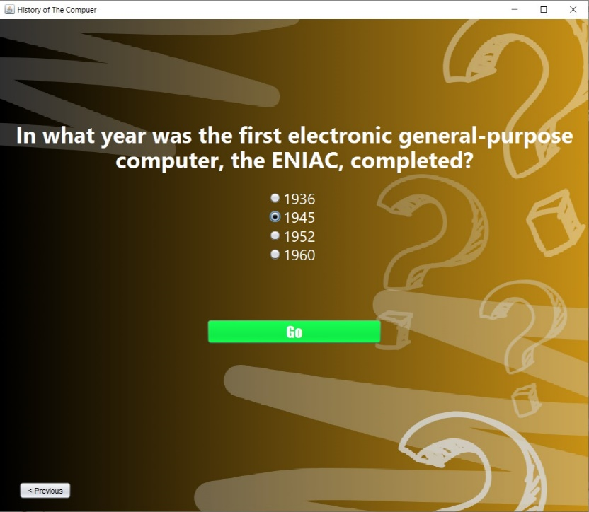

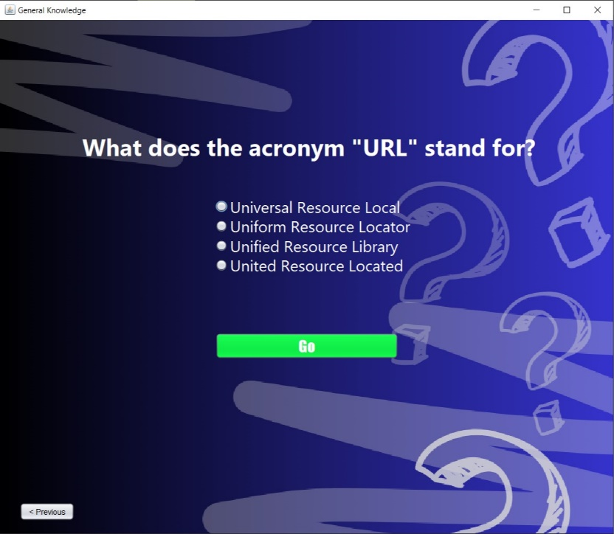

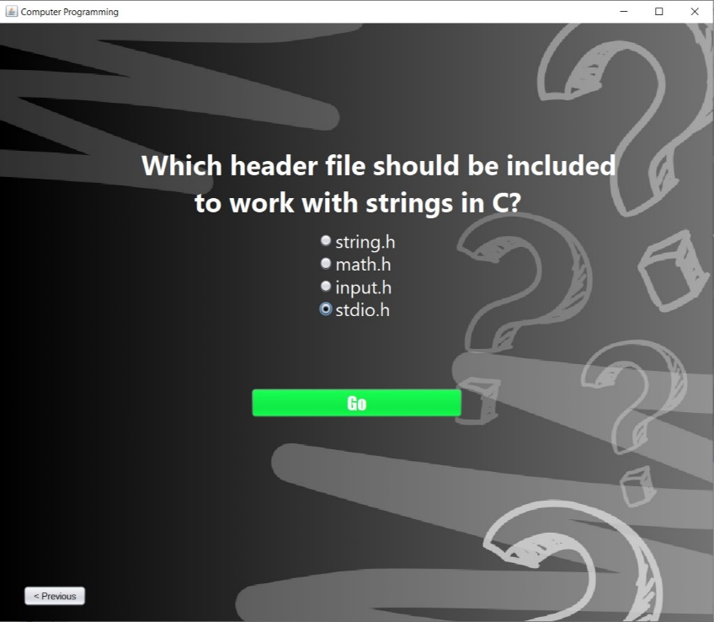

## 

## **4 Methods and Technology Used**

Mainly this app will be developed by using C language and Visual Studio Code text editor will be used as the platform. Java language will be used to develop the interface of this quiz game. Lucid chart software is used to design the flow chart.

Gathering idea from the team

Requirement Analysis

Create the algorithm/

pseudocode

ppalAlgorithm/pseudocode

Coding part

Testing

Final product

The software model used is the classic lifecycle model.

*Waterfall Process model*

The classical life cycle or waterfall process model was the first process model to present a sequential framework, describing basic stages that are mandatory for a successful software development model. It formed the basis for most software development standards and consists of the following phases: Requirement analysis, design, coding, testing, and maintenance.

# 

# **Development**

## **Solution**

The specific functions implemented in a quiz game project can vary depending on the design and requirements of the game. However, I can provide a list of common functions and features that are typically implemented in a quiz game:

1.User Registration and Authentication:

User registration and login to create and manage player profiles.

2. Question Display:

Displaying quiz questions with answer choices.

3.Scoring and Leaderboards:

Awarding points or scores for correct answers.

Tracking and displaying player scores on leaderboards.

4.Progress Tracking:

Showing the progress of a player in a quiz, including the number of questions answered.

5.Game Over and Results:

Displaying the results and scores at the end of a quiz.

Providing options for players to replay or start a new game.

# **Conclusion**

The online quiz application provides facility to play quiz anywhere and anytime.it save time user dose need to wait for result. So student/user cannot wait for the result. All student/user get extra knowledge and skills. Administrator has a privilege to put as much as question in any category given in application. User can register, log-in, and give the test with his/her specific id, and can see the results as well.

**References**

* Group Mentor
* IEEE
* YouTube
* W3schools
* <https://www.lawinsider.com/dictionary/technical-approach>.
* <https://www.techtarget.com/searchcio>
* <https://www.ucl.ac.uk>.